The WGHS Library catalogue on Sentral
In the Sentral Menu select Library Enquiry.

Click here

Type the title, author, subject or keyword into the search box and click on the search box.
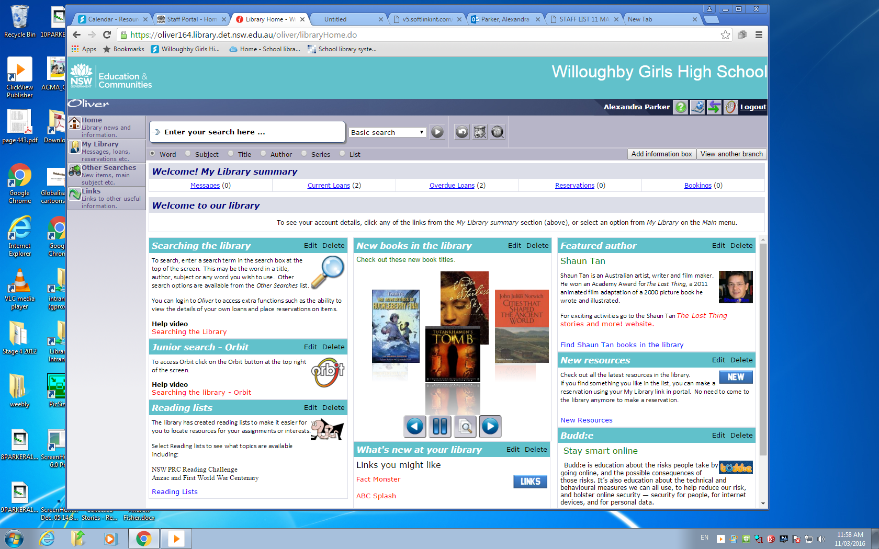

Below is an example of a results screen, following a search for Ancient Egypt.
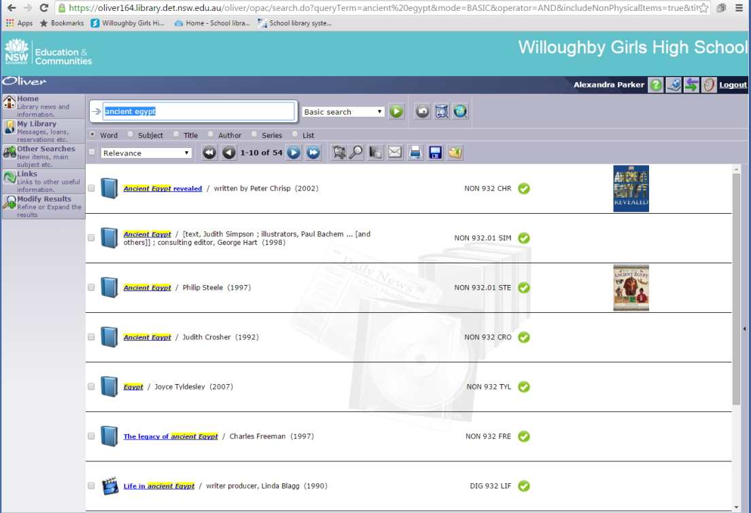

Tick indicates resource is available.

Indicates location in collection.
Indicates type of resource.

If you would like assistance in identifying, finding or locating a resource please ask the teacher librarian or at the library desk.

